Data Engineer Assessment
Test Duration: 3 days
Number 1
Lion Parcel is growing logistics company. Lion Parcel was first announced in 2013, and now the company has millions of daily transactions.
In a growing logistics company, Business Intelligence is a must, to provide analysis and recommendation. Therefore, one of the importance is Data Engineer, is to provide the data that is ready for analytical purpose.
One of the most critical data in Lion Parcel is Retail Transactions (make your own data dummy)
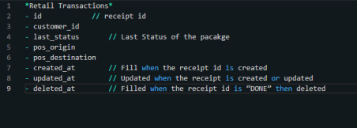Your Task:
1. Design and create an ETL/ELT process using any data pipeline tools you are familiar with (Preferably Airflow), to transfer data from a database (SQL or NoSQL) into a data warehouse (choose the one you are most familiar with). The DDL of the target table is attached in the image. The ETL/ELT will run each hour everyday.
2. What if the table uses the soft delete method? In this approach, when data is deleted, the row is not physically removed but the deleted_at column is updated with the timestamp of deletion. The data in the data warehouse and the database should remain in sync, while still preserving the deleted rows for historical or auditing purposes.

Number 2
Create a program with the following requirements:
- The program must provide an API endpoint that can be accessed via an HTTP request.
- The endpoint must accept an image URL as input.
- Perform blur detection on the image:
If the image is detected as blurred, the API must return:
- If the image is not blurred, then:
The program must use the OpenAI API (free token) to describe the content of the image in text form.
- The endpoint must return the final result as:
"blur" if the image is blurred, or the image description generated by OpenAI if the image is not blurred.
{
"image_url": "http://localhost/{link_image}"
}

Example Response
If the image is blurred
{
"result": "blur"
}
If the image is not blurred
{
"result": "A woman is sitting in front of a laptop inside a room..."
}
- Summary your result based on the image in folder Number 2: Image Dataset into csv file

🚨 NOTE
Dockerize all your code (1, 2). Put your Dockerfile and all the necessary scripts on Github. To persist the files, you can use a volume which mounts to the local disk. Provide complete information on how to create and run your Docker container on README.

